

SOMALI WOMEN VISION INTERIM REPORT

Long term Cash and Livelihoods Intervention (LTCL)
EYL DISTRICT

Service Provider | Somali Women Vision (SWV) | Period | From | To
Service Provider | Somali Women Vision (SWV) | Period | 12th February 2022 | 30th June 2022
Regions | Nugaal Region | Districts |  | Eyl District

1.0 General Progress Report - Paragraph

1 | Sequencing with other agencies:- Did the SP do sequencing in the district? | SWV did sequencing with Action Against Hunger, World Vision International and IRC. These organizations were working in the district and SWV built collaboration with them.
2 | Mobilize and sensitize regional and district authorities, in close consultations with local administration, communal elders and relief committees:- | - Meeting with the Director General, Ministry of Fishery and Marine Resources  Somali Women Vision team led by the executive Director and the project manager met with the Director general, Ministry of Fisheries. The aim of the meeting was to introduce the core objectives of the program to the Ministry and explain to them the modality of executing the project.  SWA executive Director explained to the Ministry team that FAO is funding the project and SWV is implementing the activities of the project. Mrs.Hawo explained to the team on key expected outcome and she said that the project would ensure that households have sustained or improved food security status through continued cash assistance and diversified livelihood options through inputs combined with saving group support.  The project manager of SWV mentioned that they will conduct a series of activities aimed at achieving the outcome of the project and they will establish greater working relations with the regional and district level administration.  The Director General of the Ministry welcomed the initiative and expressed their delight for the support of FAO in food security and diverse support to the people of Puntland  - Meeting with Eyl District Mayor and Council Members  SWV team went to Eyl and held consultations with the district administration. The consultation was attended by the district mayor, deputy mayor, council members and selected community committees.  SWV team provided information on the project outcome and expected outputs. The team also explained the funding organization and the implementing organization. The team explained the core activities to be conducted, the selection criterion of the beneficiaries and most particularly selection of beneficiaries of FAO
3 | Village identification with mandatory collection of GPS coordinates after consultation with authorities, other implementing agencies as well as nutrition partners implementing feeding programs:- | SWV team made consultation with the communities in four location in Eyl district. The following summary presents the general information of the participants disaggregated by gender and key issues presented as well key issues raised.
5 | Training of beneficiaries on agri-nutrition and food safety:-Has the Nutrition champions trained other beneficiaries :- | SWV trained 8 nutrition champions and the champions further trained the project beneficiaries on food agri-nutrion and food safety. Every two champion in specific location trained the beneficiaries from the village. The total number of persons trained by the beneficiaries is 221 82 are male while the female are 139  The trainees acquired practical lesson on how to preserve foods and the key nutritious components of the available foods.
6 | Collection of nutrition baseline data using ODK/excel | SWV collected the baseline nutrition data using ODK and shared with FAO through the system generated by FAO.
7 | Three human interest stories:- provide 3 stories | See Annexes: Human Interest stories
8 | Report on actions taken against the SP’s internal risk mitigation and monitoring framework; - provide the information | The overall risk rating of the project was moderate. The assumed risks included insecurity which could be a threat to the staff of the organization and that impacts on the project implementation.  The project team didn’t meet any insecurity incident.

Table 1: Summary of community Mobilization meetings
S/N | Location/Venue | Dates of the Meeting | # of council elders who attended | # of women | # of men | Subjects discussed | What was agreed
 | Ministry of Fisheries- DG Office | 10/08/2021 | 4 | 2 | 2 | - Goal of the intervention  - Project activities  - Planned outputs and opportunities available  - The rate of cash transfer  - Overall program implementation and timeline | - The Ministry approved the plans shared and notified they will provide key support needed, provide joint monitoring mission
 | Eyl Local government | 15/8/2021 | 9 | 4 | 5 | - Goal of the intervention  - Project activities  - Planned outputs and opportunities available  - The rate of cash transfer  - Overall program implementation and timeline | - Expressed commitment to support verification and re-registration of beneficiaries.
 | Garab Haar | 16/8/2021 | 6 | 1 | 5 | Project information, selection process and criteria, total number of beneficiaries for the district, amount of cash transfer, implementation modalities, | Presented their views and information will be collated.
 | Dawad | 17/8/2021 | 18 | 8 | 9 | Project information, selection process and criteria, total number of beneficiaries for the district, amount of cash transfer, implementation modalities, | Presented their views and information will be collated.
 | Baday | 17/8/2021 | 20 | 4 | 16 | Project information, selection process and criteria, total number of beneficiaries for the district, amount of cash transfer, implementation modalities. | Presented their views and information will be collated.
 | Maraye | 18/8/2021 | 16 | 6 | 10 | Project information, selection process and criteria, total number of beneficiaries for the district, amount of cash transfer, implementation modalities. | Presented their views and information will be collated.

Accountability to affected populations
SWV is implementing the project in a very collaborative manner that the beneficiaries were given the opportunity to be involved in the project. SWV team consulted with the communities in four location in Eyl district. The following summary presents the general information of the participants disaggregated by gender and key issues presented as well key issues raised.

A code of conduct exists that explicitly addresses protection of people the agency seeks to assist from sexual abuse, corruption, exploitation and other human rights violations, and: The code specifically refers to staff, volunteers and partners not exploiting and abusing people, and the responsibility of staff to report abuses. The codes are shared with affected communities so that they know what to hold workers, partner staff and volunteers to account for. Safe and effective grievance procedures exist and the agency takes appropriate disciplinary action against workers following confirmed violation of the code of conduct.
The organizations and their partners talk to the people they seek to assist about their information needs and preferences for channels and means of communication from the initial assessment phase, and demonstrate a commitment to routinely providing accessible and timely information to the affected population about:
- The humanitarian agency, its accountability commitments, code of conduct, complaints procedure and relevant contact details Projects, including goals and objectives, expected results, timeframe, summary of finances and evaluation/ progress reports
- People’s rights and entitlements
- Processes that affect them to ensure that they can make informed decisions and choices,
- Staff roles and responsibilities
- Criteria for selecting target groups
- Feedback from participatory processes
- How the organisations can be held accountable for meeting its stated commitments

COMMUNITY AWARENESS ON COVID-19.
Somali Women Vision team sensitized the community members on the risk of COVID-19. The team and the district administration on the key prevention measures of COVID-19. The team also encouraged communities and the project team to mains proper hygiene,
Most people in and around Eyl have been exposed to the Covid 19 vaccine.
Awareness includes a distancing of 2 meters, wearing a face mask and washing your hands.

COMPLAINTS AND GRIEVANCES
SWV set a manual complains and grievance system that allowed beneficiaries to directly call the project management team and sometime the grievances were presented during the project team visits to the villages.
SWV sensitized the beneficiaries on the FAO hotline number and were encouraged that the call free toll number is available whenever they want make a contact with FAO.
Most of the complaints were handled in a satisfactory manner, most key issues related to the beneficiaries whose family members died and were in the registration process so their families complained that this was their right but we convinced them that we are targeting beneficiaries with certain criteria and if the person died, we will replace with someone from the community who is vulnerable and that the process is not inheritance.
VSLA Activities
Village Savings and Loans Associations (VSLAs) are thought to play a critical role in bringing financial services to rural areas of developing countries, where access to formal financial services is typically very limited.
SWV established VSLAs at the villages. Twelve VSLA groups have been formed. 6 in Baday, 2 In dawad village, 3 in Mareye village and 1 in Garabhaar.
SWV did follow up of the implementation of the VSLA, 9 groups out of the 12 groups have made a share out, and the 9 groups have promised to resume a new round of VSLA, They told us that they will start the 2nd round on the 10th of April, if God willing.
The following are the Group names.
Name of Group | Village | Number of Males | Number of Females
Maraye A 2 | Maraye | 2 | 13
Garab Haar A 1 | Garab Haar | 7 | 12
Dawad A 1 | Dawad | 18 | 17
Badey A 1 | Baday | 4 | 21
Badaey A 2 | Badey | 0 | 25
Maraye A1 | Maraye | 6 | 20
Badey A 3 | Badey | 5 | 20
Badey B 3 | Badey | 0 | 15
Dawad B1 | Dawad | 6 | 9
Baday B 1 | Badey | 11 | 9
Badey B 2 | Badey | 7 | 8
Maraye B 1 | Maraye | 7 | 10
The training provided to the beneficiaries includes
VSLA methodology, principles, best practices and standard operational procedures, implementation strategies, systems and structures, community mobilization and participatory training skills, key VSLA data collection/reporting tools
Badey VSLA Male is 32 while female is 66, Dawad village VSLA Male 12 Female 34 Garabhar Village VSLA is 10 while females is 9 in Maraye VSLA male is 28 and females is 30
As swv we have taught the beneficiaries the following lessons about life skills
- Skills of making effective decisions
- Skills of knowing and living with others
- Skills of knowing and living with oneself
- Sexual and reproductive health (menstruation, early pregnancy, STI/ HIV prevention, family planning, etc.)
- Leadership
- Gender and bride price
- Rape (meaning, prevention strategies, responding and coping)

PSEA Report
Somali Women Vision established mechanisms that prevent and sanction sexual exploitation or abuse at all times during implementation of projects. Any act of SEA constitutes serious misconduct and allegations should be reported immediately to the senior management and particular attention is given to gender-based violence unit as well the human resource office.
SWV PSEA policies and practices aim to end sexual exploitation and sexual abuse by humanitarian workers, including SWV personnel, and ensure that allegations of SEA are responded to in a timely and appropriate manner.
SWV have a zero-tolerance policy with regard to sexual exploitation and abuse. It is considered serious misconduct and can have severe consequences.
SWV personnel are strictly forbidden to engage in sexual activity with children (persons under the age of 18), regardless of the local age of consent or majority.
SWC ensured that an effective anonymous and confidential complaint mechanism exists. The complaint mechanism should be accessible to complainants and they should feel that it is easy and safe to use.
SWV ensured that victims of SEA have access without delay to the support they need – to be safe, or to obtain basic material assistance, medical care, psychosocial support, or legal services. Usually, such support is provided through SGBV response services. Clear referral pathways should be established to ensure that all SEA survivors can access all the SGBV case management services they need.
In the implementation of these SWV carried out necessary steps to meet the mechanism established:
- Ensure that all newly recruited staff and members of the affiliate workforce are cleared by the database of the UN agencies before they are issued a contract or letter of offer.
- In collaboration with stakeholders, assess and map potential risk areas by sector and discuss actions that can reduce the risk of SEA and prevent and sanction it.

During the mobilization and sensitization, the beneficiaries were informed that they shall be vigilant from any person who tries to exploit them sexually using the name of the agency, government agency or local committees.
Verification and reregistration of the beneficiaries was closely monitored so that gatekeepers ( village brokers) don’t lure vulnerable groups into sexual exploitation for promising them to include in the registration process.

SWV is women led and women activist NGO and has zero tolerance for Physical and Sexual Exploitation and abuse.

Summary of monitoring activities conducted:

List the type of monitoring missions conducted | - Monthly and Bi-Monthly Monitoring | Service providers staff name | Mohamud Juqurafi
List the type of monitoring missions conducted | - Monthly and Bi-Monthly Monitoring | Service providers staff title | M&E Officer
List the type of monitoring missions conducted | - Monthly and Bi-Monthly Monitoring | Mission date | 1st September 2021- 15th December 2022
Number of beneficiary targeted |  | Project beneficiaries
List of stakeholders interviewed (beneficiaries/ elders etc) |  | - Village committees  - District administrations  - Women groups  - Youth (Male and female) groups
Number of call actions made by the NGO to beneficiaries to date |  | We made calls using our mobile phones, we called all the beneficiaries at least 7 different times for awareness, we talked about turning on their cell phones and never turning them off, we also talked about how to pay for it. Come and share with us any challenges they face
Do you have a complain mechanism in place? |  | We have a manual complains mechanism in place. We provide project team contacts so that beneficiaries can contact whenever there is complain.
Highlight major cases received and how they were resolved internally |  | - Missing beneficiaries’ families complain- The persons who were not reached during the verification. The family members wanted their name to be changed in the place of the missing beneficiary. The complain was resolved by convincing the family of the unreachable beneficiaries that the selection process doesn’t consider next of kin scenarios but is based on set of criterion that are pre-determined to avoid biasness since they don’t meet such criteria and they can’t be added to the list.  - Delay of the equipment- The beneficiaries called persistently on the delay of the equipment. We convinced them that the procurement process is taking time and it will be delivered by FAO in collaboration with SVW.
Provide GPS photographs during the interviews and the actual implementation of the activities (folder containing the photographs should also be provided) |  | I will share with you another email insha allah the pictures

Table 1: the progress made so far against the work plan
Provide brief summary of project activity target as per the LOA (Units, HH, numbers etc.) | Actual achievements against set targets up to the date of reporting | Remarks (ACTIONS / Recommendations)
Mobilization:. | Mobilization and sensitization of regional, district and village committees. The mobilization meeting also provided information to the participants regarding the selection process and the selection criterion. It was clear elaborated and clarified that the beneficiaries will be prioritized from a pool of existing beneficiaries previously supported by FAO. | SWV successfully completed the process and submitted report highlighting the outcome of the mobilization process, community engagement and feedback from the participants
MMO Verification: | SWV conducted verification of the Phase two Mobile Money organization. We cross checked the list and when the money was due to be process, we called the beneficiaries to be alert and wait for their money.  Following the disbursement of the First MMO, SWV once again carried verification of the beneficiaries on whether they received the money | SWV recommends the disbursement of the remaining installments on timely manner
Nutrition champion Training; | SWV through its nutrition focal point selected 2 nutrition champions from each location (one female and one male). The nutrition champions were selected based on the criteria outlined in the terms of reference for the project. The champions were trained for 3 days on three key areas including (1) feeding your family (2) Food safety and hygiene (3) water sanitation and hygiene.  . | The training was successful as the participants gained knowledge and skills on how to practice feeding programs, food and hygiene safety as well water sanitation and hygiene
Villages saving and loans association (VSLAs). | SWV trained the beneficiaries on how to establish VSLA. The training was on hands practical. The key outcome of the training was the development of VSLA bylaws. The bylaws were comprehended fully.  12 groups of VSLA were formed categorized as follows  - Baday 6 groups  - Dawad 2 groups  - Mareye 3 groups  - Garabhar 1 one  There was also lifeskills training, which was very helpful to the beneficiaries things that we think will help include:  - That everyone can work on their own, to help his/her family  - That anyone can be a teacher or coach, and from there develop something to help their family | 9 groups are share out and They told us that they will start the 2nd round on the 10th of April, if God willing.  the remaining 3 are sharing out 5th April 2022 insha allah
Beneficiary Payment Distribution: | The payment to the beneficiaries reached 287 for the Ten months. The total payments to the beneficiaries so far is $80,360
Input Distribution in LTCL project | There is delayed distribution of inputs from FAO 10.3M boats | SWV recommends FAO to harness the input distribution as urgently as possible. 10.3M boats

Internal Risk mitigation
SWV has put in place internal risk mitigation measures through its risk management policy that clearly capture; where an unacceptable risk is identified, relevant organization staff with management responsibilities in areas that may be affected will be informed of it. They will be required to take action as required, to address the matter and inform staff or other persons within their areas of responsibility, about the matter.
In the implementation of the project SWV had already proposed some risk mitigation measures were proposed.

 | Key Risks in North Galkayo | Chance (High, Medium or Low) | Impact | Mitigation measures
1. | Deterioration of security situation preventing access to project sites | Medium | Beneficiaries become unreachable; project staff security is at risk. | - SWV Adhered to established security protocols  - SWV Maintained regular contact with authorities and community leaders, agencies operating in the area as well as NGO Safety Project (NSP) to make informed choices.
2. | Selection of project beneficiaries causes tension between communities | Medium | Conflict within communities breaks out between beneficiaries. | - Selection of beneficiaries was done through list provided by FAO with consultation with the community members. SWV carried out verification and reregistration.

Monitoring and Evaluation

SWV conducted monthly and bi-monthly monitoring missions. Our monitoring missions are built within the project activities. Our Monitoring officer collected disaggregated data on gender of beneficiaries.
The key participants include Village committees, district administrations, women groups and youth (Male and female) groups.

Key Issues of the Monitoring and Evaluation
- Missing beneficiaries’ families complain- The persons who were not reached during the verification. The family members wanted their name to be changed in the place of the missing beneficiary. The complaint was resolved by convincing the family of the unreachable benefactrices that the selection process doesn’t consider next of kin scenarios but is based on set of criterion that are pre-determined to avoid biasness since they don’t meet such criteria and they can’t be added to the list.
- Delay of the equipment- The beneficiaries called persistently on the delay of the equipment. We convinced them that the procurement process is taking time and it will be delivered by FAO in collaboration with SVW.

Annex 3: Gender Report

NGO name, location, livelihoods, beneficiary target, LoA Number | Somali Women Vision,  Eyl District  UCT- 287 Target beneficiaries.  LOA# 87-2021 Phase 1B
Existing gender relations in the area of operation (how do men and women relate to each other) context or environment they are working at | They have good working relations that is mutual and the districts enjoys favorable working atmosphere.  we took it  that we interviewed everyone individually,  We looked at the way they work together, and their behavior during work hours at that points it proves to us that people have a real relationship.
Existing gender relations in the area of operation (how do men and women relate to each other) context or environment they are working at | They have good working relations that is mutual and the districts enjoys favorable working atmosphere. They respect each other's work as we have seen in the past,
How was mobilization and awareness conducted? What consultations were done? Who participated in the consultations? How many men or women? | SWV team made consultation with the communities in four locations in Eyl district. The following summary presents the general information of the participants disaggregated by gender and key issues presented as well key issues raised.  SWV team presented in this meeting the following information:  - Goal of the intervention  - Project activities  - Planned outputs and opportunities available  - The rate of cash transfer  - Overall program implementation and timeline  The meeting also provided information to the participants regarding the selection process and the selection criterion. It was clear elaborated and clarified that the beneficiaries will be prioritized from a pool of existing beneficiaries previously supported by FAO.  The team also explained the FAO selection criterion which included the following key considerations.  - Shall be resident/internally displaced persons of the designated village in Eyl district  - Shall be among the pool of beneficiaries who received emergency assistance from FAO  - Among the pool of beneficiaries from FAO, the following shall be given priority  - Lactating and pregnant women  - Households with children below 5-years of age  - Households with elderly persons above 65 years of age  - HH with malnutrition persons (coordination with nutrition cluster)  - Female headed households shall be prioritized.  - At least 30% of the beneficiaries shall be women.
Are there village women committees? | Yes  Villages  Villages Badey and Maraye have a committee that includes women  for example,Mayare Have 15 committee members 10 of them are female while 5 are Male the Badey village have 30 committee 24 are female while 6 are male.  Garab haar have 5 committee 3 are male while 2 are female. Dawad have 10 committee 3 are male while 7 are female
How did you select beneficiaries? How many dependent households are participating in the project? | The selection was based on the following criteria  - Shall be resident/internally displaced persons of the designated village in Eyl district  - Shall be among the pool of beneficiaries who received emergency assistance from FAO  - Among the pool of beneficiaries from FAO, the following shall be given priority  - Lactating and pregnant women over 12 are pregnant women while the lactating women was 9 at that time  - Households with children below 5-years of age  - Households with elderly persons above 65 years of age  - HH with malnutrition persons (coordination with nutrition cluster)  - Female headed households shall be prioritized.  - At least 30% of the beneficiaries shall be women.
What roles do men and women say they can do in the identified activities? | Women can be very support in all the activities including- The nutrition champions, Village loan and saving association, village committee among other key roles
Are there cultural constrains or restrictions that affect women activities in the participation in the farming activities | No there no cultural constrains. After a lengthy interview we were told, with the collapse of the central government of somalia in 1991 women were the backbone of somali families, in terms of production and there were no barriers to their participation in community development, we interviewed especially women beneficiaries of this project they even told us.  There is no culture or challenge faced by Somali women in general and those in Eyl district in particular who are benefiting from this project.  In some places women may be pressured not to work or to do something but this is not the case in our area.
What time do women compared to men prefer start working at? Were women consulted separately on the best time for them to provide labor to the activities? | Yes, we consulted with women in particular, and they told us that they have enough time each day for 4 hours every day.
Will women and men work alongside each other? If yes, are there challenges to women and men working a long each other at different activities? | Yes they can work along each and there are no challenges.
What other concern do women and men have? | There are no concerns from both men and women.

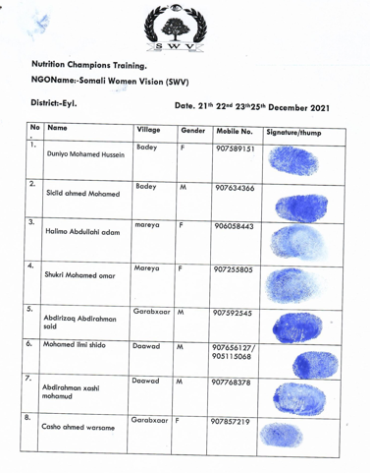

Project Photos

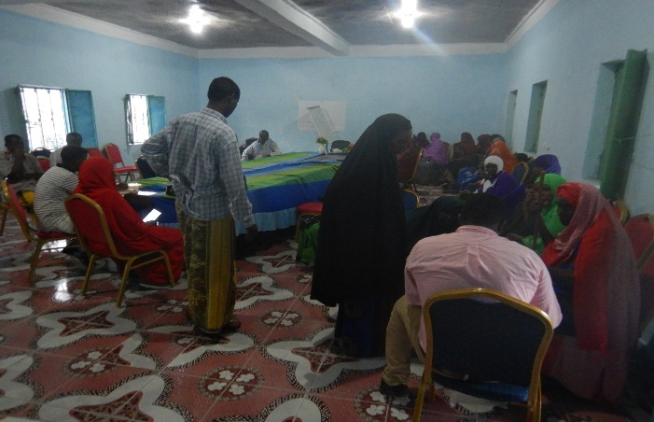  Mobilization photos of Dawad Beneficiaries | 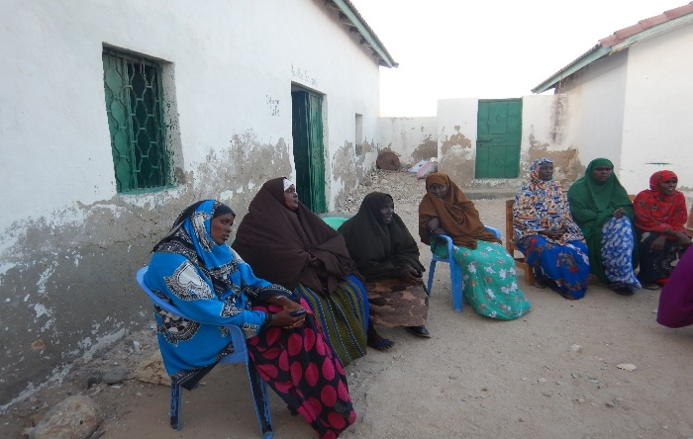  Mobilization photos of Badey Beneficiaries
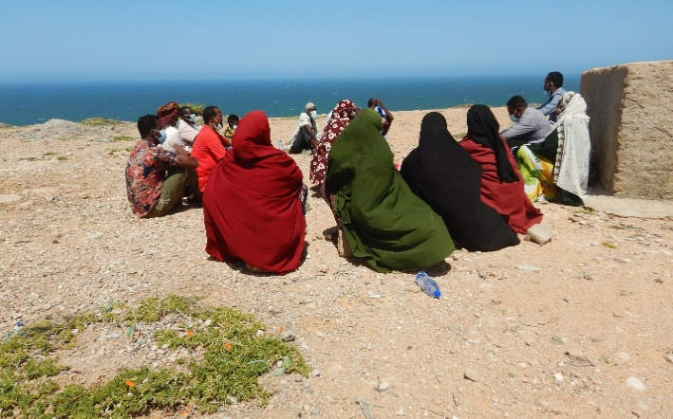  Mobilization photos of Garab Har Beneficiaries | 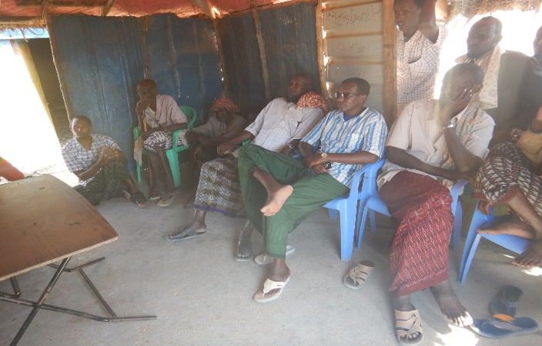  Mobilization photos Maraye Beneficiaries

Human Interest Story one Insert a paragraph and photos

INSTRUCTIONS
PLEASE ANSWER EACH QUESTION CLEARLY AND COMPLETELY IN ENGLISH. TYPE LEGIBLY. READ CAREFULLY AND FOLLOW ALL DIRECTIONS.
- Contact details
- Name of person compiling case story: Mohamed Said Farah
- Telephone contact: 907700164
- Date: 07/02/2022
Beneficiary Profile
2.1 Personal information
Name: Shukri Ahmed Diriye
- Gender : Female
- Age :35
- Occupation: UCT
- Number of children: 6
- Telephone contact ): 0907272062
- Is the beneficiary the head of the family):
- Location of the place living now :
  - Village: Garab Haar
  - District: Eyl
2.2 Household income, expense statements from the beneficiary.
2.2.1Income and Expenses :
- Employment: (Give information of your current job or, if you are unemployed, your most recent job): N/A
- Employer: If unemployed, date job ended: N/A
- I get paid (net income in USD) xxx $ per month, or xxx per week, or xxx $ per hour. N/A
- Other forms of employment (if you have more than one source of employment) N/A
  - Other source of household incomes: Relative and aids from the huminaterian
  - Total average income per month this current year (USD):70
  - Total average expenses per month last year (USD): 35
  - What did you spend your incomes on? (Please tick)
  - Food
  - Education
  - Health care
  - Farm investment
  - Other N/A
2.3 Household’s Wealth and asset status
- Farm size (ha):N/a
- What crops do you grow? N/A
    - Crop 1 :
    - Crop 2 :
    - Crop3:
    - Number of livestock. (Please include name of the livestock and total number)
    - Livestock 1 Camel 0
    - Livestock 1 Cow0
    - Livestock 1 Goat 0
- Name type of Long Term Cash and Livelihoods in Eyl District
the beneficiary are perticpating fishing activities
The beneficiary’s needs, problems or issues before the joining the UCT activity
List the main needs / issues for the beneficiary (Please elaborate).
- After the drought effected these areas, it swept all the assests including animals.therefore beneficiaries need aids.
- Beneficiaries weres not able to meet their needs.
- Their remaining animals ware having lack of pasture and water
5. Please include a statement from the beneficiary. Use the questions below:
- How did you first come into contact with the project?
I got the information from the community elders after when NGO meet with the elders.
- How were you selected to join the project?
I was feeted the criteria that the NGO come with as and the condition that was been told the elder to select the beneficiary from the village.
- What has changed as a result to your household due to your involvement with the project?
It has changed many thing like now I’m able to provide my family daily meal and take care their health.

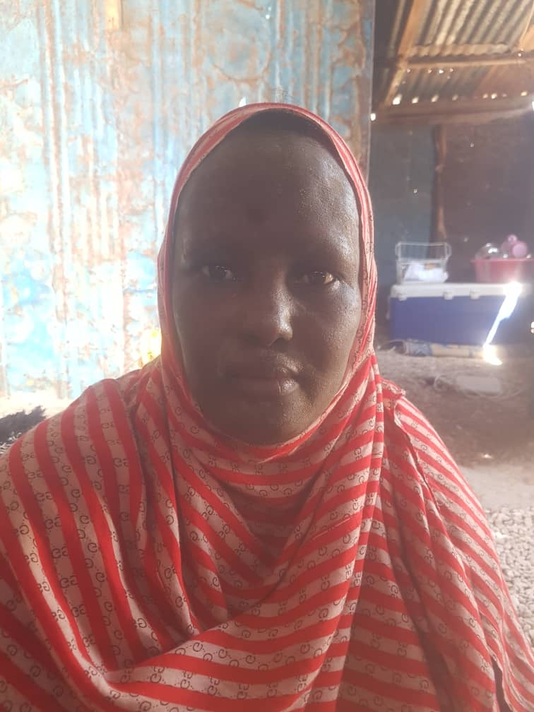 | 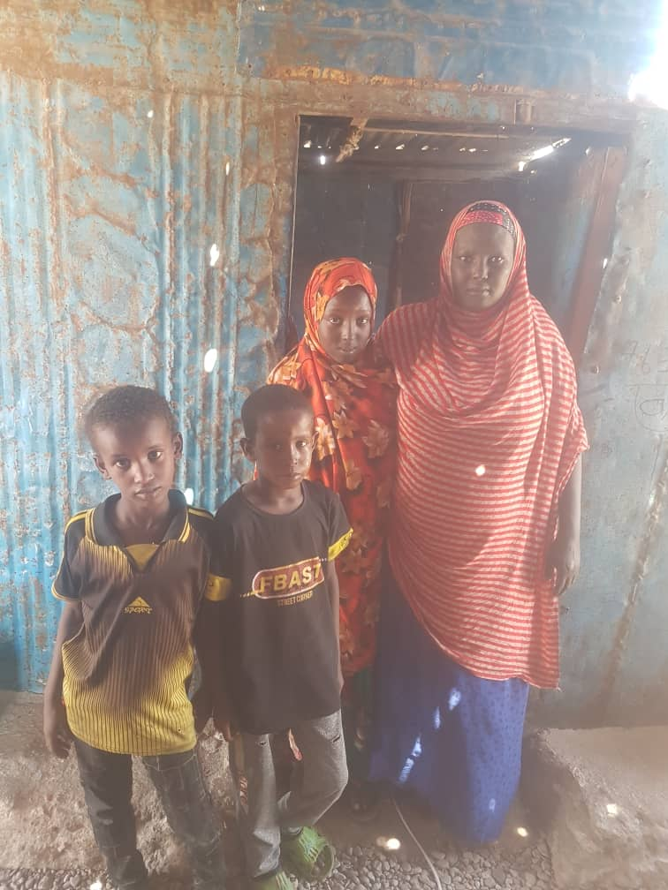
Beneficiary Photographs | Beneficiary Family photographs

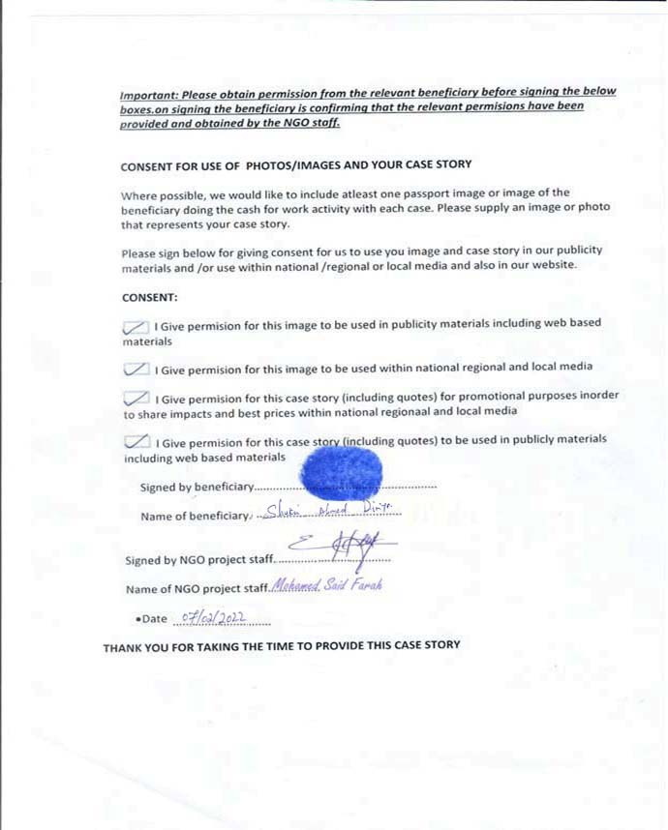

Annex: 2
- Human Interest Stories

INSTRUCTIONS
PLEASE ANSWER EACH QUESTION CLEARLY AND COMPLETELY IN ENGLISH. TYPE LEGIBLY. READ CAREFULLY AND FOLLOW ALL DIRECTIONS.
- Contact details
- Name of person compiling case story: Mohamed Said Farah
- Telephone contact: 907700164
- Date: 07/02/2022
Beneficiary Profile
2.1 Personal information
Name:- Fatima Abshir Mohamed
- Gender : Female
- Age : 40
- Occupation: UCT
- Number of children: 8
- Telephone contact ): 0907265871
- Is the beneficiary the head of the family):
- Location of the place living now :
  - Village: Dawad
  - District: Eyl
2.2 Household income, expense statements from the beneficiary.
2.2.1Income and Expenses :
- Employment: (Give information of your current job or, if you are unemployed, your most recent job): N/A
  - Employer: If unemployed, date job ended: N/A
  - I get paid (net income in USD) xxx $ per month, or xxx per week, or xxx $ per hour. N/A
  - Other forms of employment (if you have more than one source of employment) N/A
- Other source of household incomes: Relative and aids from the huminaterian
- Total average income per month this current year (USD):70
- Total average expenses per month last year (USD): 30
  - What did you spend your incomes on? (Please tick)
    - Food
    - Education
    - Health care
    - Farm investment
    - Other N/A
2.3 Household’s Wealth and asset status
- Farm size (ha):N/a
- What crops do you grow? N/A
    - Crop 1 :
    - Crop 2 :
    - Crop3:
  - Number of livestock. (Please include name of the livestock and total number)
    - Livestock 1 Camel 0
    - Livestock 1 Cow0
    - Livestock 1 Goat 7
- Name type of Long Term Cash and Livelihoods in Eyl District
the beneficiary are perticpating fishing activities
the beneficiary are perticpating cash for work activities such water catchment Contor bounds and Canals
- The beneficiary’s needs, problems or issues before the joining the UCT activity
List the main needs / issues for the beneficiary (Please elaborate).
- After the drought effected these areas, it swept all the assests including animals.therefore beneficiaries need aids.
- Beneficiaries weres not able to meet their needs.
- Their remaining animals ware having lack of pasture and water
5. Please include a statement from the beneficiary. Use the questions below:
- How did you first come into contact with the project?
I got the information from the community elders after when NGO meet with the elders.
- How were you selected to join the project?
I was feeted the criteria that the NGO come with as and the condition that was been told the elder to select the beneficiary from the village.
- What has changed as a result to your household due to your involvement with the project?
It has changed many thing like know I’m able to provide my family daily meal and take care their health.

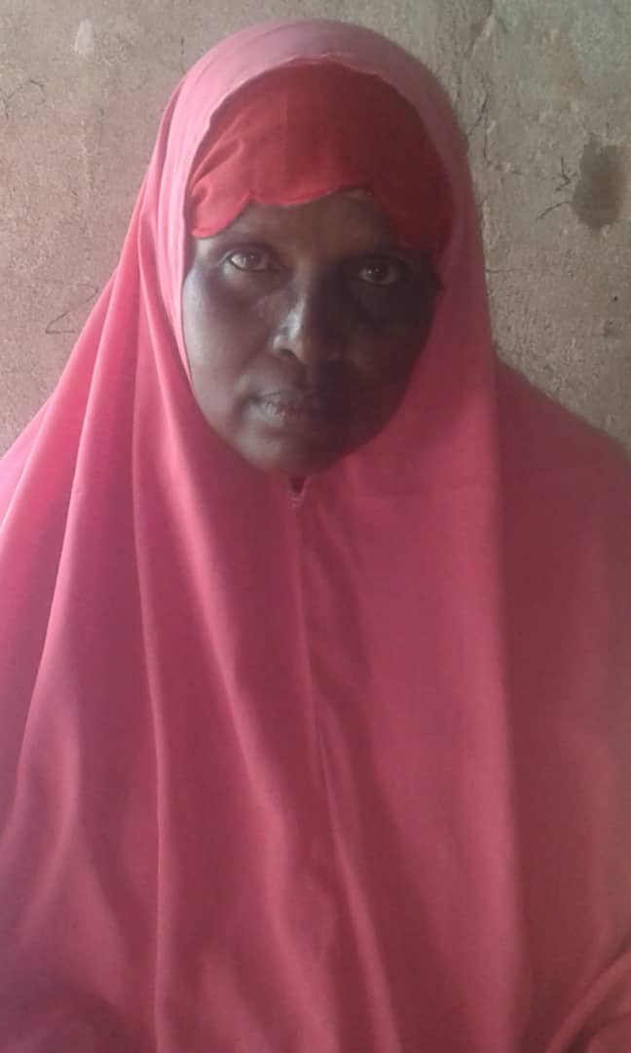 | 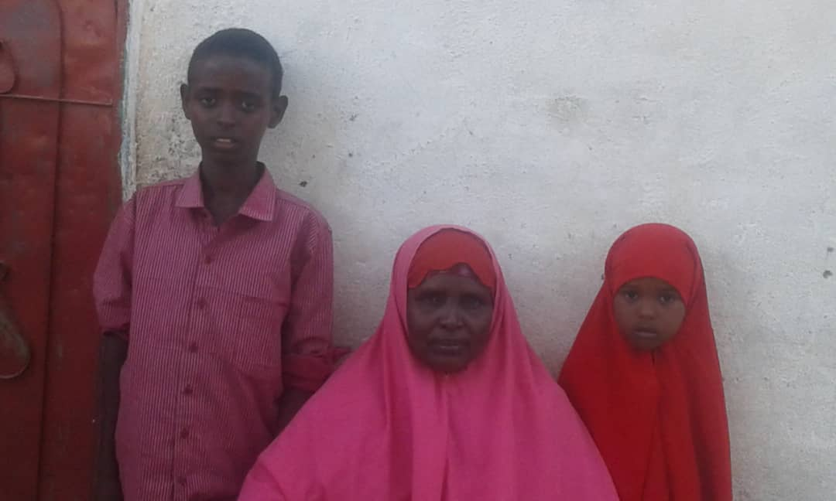
Beneficiary Photographs | Beneficiary Family photographs
